**FIRST COMMERCE BANCORP, INC., ANNOUNCES**

**ADDITIONS TO ITS BOARD AND MANAGEMENT**

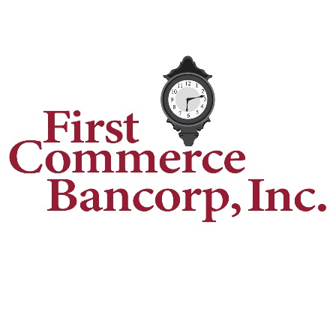

Lakewood, N.J., February 26, 2025 – First Commerce Bancorp, Inc., (the “Company”) (OTC: CMRB), the holding company for First Commerce Bank, (the “Bank), proudly announces the addition of several individuals to the Bank’s Board of Directors and Management Team. The Bank has added two new members to its Board of Directors: Mr. Aaron Bookman and Mr. Stanley Koreyva.

Commenting on their attributes and experience, Chairman Thomas P. Bovino remarked, “Mr. Bookman, a seasoned corporate finance executive and CPA, brings over 25 years of experience leading large public companies. With deep roots in the Lakewood community, he has demonstrated a strong commitment to both shareholder value and corporate governance. His expertise in financial strategy and operational leadership will enhance the Board’s ability to navigate today’s dynamic financial landscape. Mr. Koreyva, a former senior banking executive, brings many years of successful and disciplined banking and regulatory experience to the Board with a fresh and independent perspective regarding relationship building and value creation. His extensive familiarity of industry challenges will assist the independent Board members in understanding the intricate aspects of today’s banking environment. We welcome both gentlemen to our Board of Directors and look forward to their contributions in the many diverse facets of the complex industry and communities that we endeavor to serve.”

Additionally, the Bank has recently bolstered its Business Development and Risk Management teams by hiring several successful senior level Business Development Officers, Community Banking Specialists and Risk Professionals. With respect to Business Development and Relationship Management, the Bank has hired: Mr. Leonard Allen, VP/Business Banking Officer; Mr. Daniel Dunn, VP/Treasury Management Officer; Mr. Matteo DiGrigoli, Retail Sales & Service Officer; Ms. Wendy Glatz-Akmentins, AVP/Branch Manager and Mr. Logan Cheow, AVP/Relationship Manager. The hiring of these experienced bankers demonstrates the Bank’s continued commitment to a superior customer experience by offering quality personalized service to our business and retail clients.

Further, as the Bank continues its organic growth by providing a more diverse menu of products and services for its clients, it is imperative that the Bank maintain robust risk management protocols. To that effect, the Bank acquired the services of Daniel Beagle, SVP/Chief Risk Officer to oversee the Risk Management function of the Bank. Mr. Beagle has a proven track record in effectively managing risk over his 30+ years in the banking and insurance industries.

On the acquisition of their talents, President & CEO Donald Mindiak commented, “through the disruption created by recent merger and acquisition activity within our industry, the Bank was able to secure the services of these exceptionally talented and experienced banking professionals. Each brings a distinctly unique and comprehensive skill set to our Bank, with a dedication to professionalism and service to customer and community alike. We are extremely proud of these hires and look forward to their positive contribution of creating an enhanced customer service experience as well as a heightened level of value creation for our shareholder base.”

**About First Commerce Bancorp, Inc.**

First Commerce Bancorp, Inc, is a financial services organization headquartered in Lakewood, New Jersey. The Bank, the Company’s wholly owned subsidiary, provides businesses and individuals a wide range of loans, deposit products and retail and commercial banking services through its branch network located in Allentown, Bordentown, Closter, Englewood, Fairfield, Freehold, Jackson, Lakewood, Robbinsville and Teaneck, New Jersey. For more information, please go to [www.firstcommercebk.com](http://www.firstcommercebk.com).

**Forward-Looking Statements**

This release, like many written and oral communications presented by First Commerce Bancorp Inc., and our authorized officers, may contain certain forward-looking statements regarding our prospective performance and strategies within the meaning of Section 27A of the Securities Act of 1933 as amended, and Section 21E of the Securities Exchange Act of 1934, as amended. We intend such forward-looking statements to be covered by the safe harbor provisions for forward-looking statements contained in the Private Securities Litigation Reform Act of 1995 and are including this statement for purposes of said safe harbor provisions. Forward-looking statements, which are based on certain assumptions and describe future plans, strategies, and expectations of the Company, are generally identified by use of the words “anticipate,” “believe,” “estimate,” “expect,” “intend,” “plan,” “project,” “seek,” “strive,” “try,” or future or conditional verbs such as “could,” “may,” “should,” “will,” “would,” or similar expressions. Our ability to predict results or the actual effects of our plans or strategies is inherently uncertain. Accordingly, actual results may differ materially from anticipated results.

In addition to the factors previously disclosed in prior Bank communications and those identified elsewhere, the following factors, among others, could cause actual results to differ materially from forward-looking statements or historical performance: the impact of changes in interest rates and in the credit quality and strength of underlying collateral and the effect of such changes on the market value of First Commerce Bank’s investment securities portfolio; changes in asset quality and credit risk; the inability to sustain revenue and earnings growth; difficult market conditions and unfavorable economic trends in the United States generally, and particularly in the market areas in which First Commerce Bank operates and in which its loans are concentrated, including the effects of declines in housing market values; the effects of the recent turmoil in the banking industry (including the failures of two financial institutions); inflation; customer acceptance of the Bank’s products and services; customer borrowing, repayment, investment and deposit practices; customer disintermediation; the introduction, withdrawal, success and timing of business initiatives; competitive conditions; the inability to realize cost savings or revenues or to implement integration plans and other consequences associated with certain corporate initiatives; economic conditions; and the impact, extent and timing of technological changes, capital management activities, and actions of governmental agencies and legislative and regulatory actions and reforms and the impact of a potential shutdown of the federal government.